**Lecture No 01**

* Intro to making a carousal with bootstrap

**Lecture No 02**

* Made a carousal with bootstrap, nothing too fancy just copy pasted some code from bootstrap documentation and added some classes.

**Lecture No 03 (Cards in Bootstrap)**

* [www.bootsnipp.com](http://www.bootsnipp.com) contain various bootstrap components that you can reading copy paste and use in your personal projects
* In this module we learn to make cars in bootstrap.

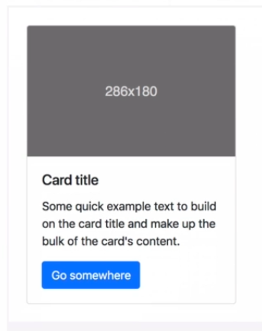

* This is what a card looks like, normally used to show various tiers of services being offered etc.
* Following is the basic structure making a card using bootstrap

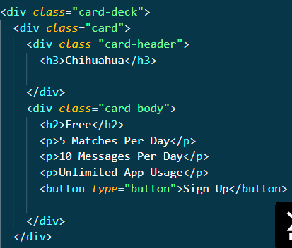

**Lecture No 04 (The CSS z index and stacking order)**

* HTML elements follow a natural stacking order i.e. the elements which come first in the HTML file lie back at the z-axis and the browser reads the html file downwards the HTML elements start coming further.

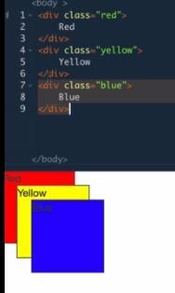

* To alter the position of an element on the z-axis we use the css property of “z-index”
* The default value of z-index for every element is 0.
* Z index only works on positioned elements (position: absolute , position: relative , or position :fixed )
* The chart below will help you navigate which element is on top when it comes to manipulating the stacking order via z-index

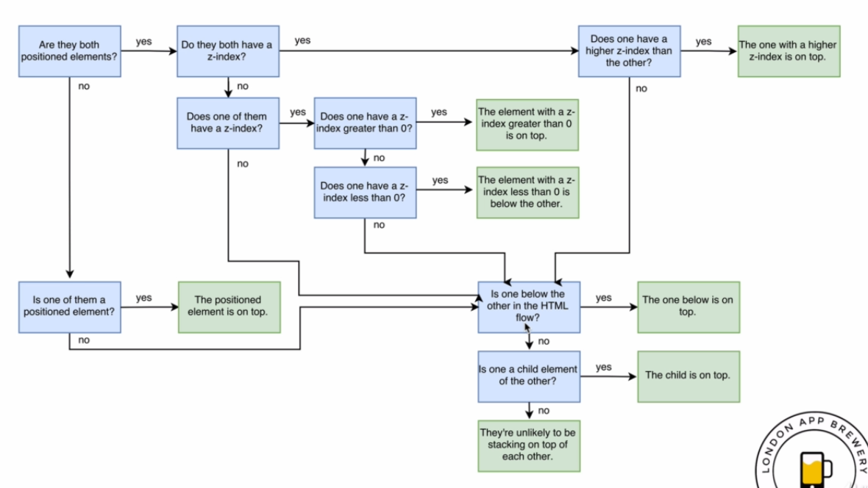

**Lecture No 05 (CSS media queries)**

* There are more people browsing websites on mobiles than on computers.
* Google penalizes you if your website is not mobile friendly.
* You can either
  + Do nothing
  + Make a completely separate site for mobile, like facebook has created m.facebook.com
  + Third, and final solution is to make your website responsive.
* There are many kinds of media queries such as print, screen and speech etc.
* The basic structure of media queries is as follows:



* For eg: if we wanna create a media query where min-width size is 900 pixels, then it would look something like:

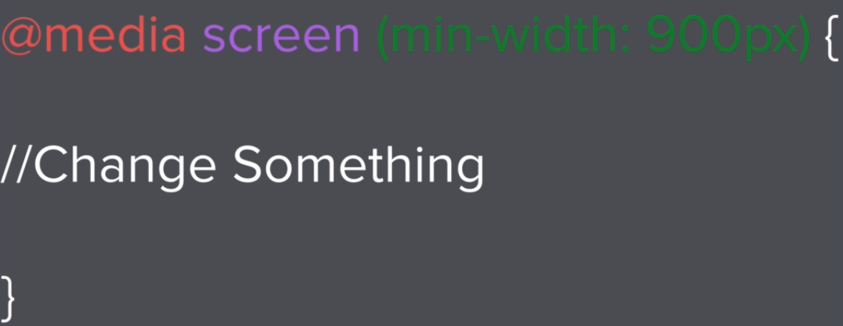

* Max-width inside a media query will affect smaller values than it. Max-width:1028px will affect all viewports (fancy word for screen sizes) smaller than 1028 pixels.
* While designing a website you can either go with mobile first approach or with web first approach, it will basically depend on the kind of business you are developing i.e. whether they are more mobile focused or more web-focused.

**Lecture No 07 (Styling the footer of tindog website)**

* Used previous knowledge to make and the style the footer of the tindog website.

**Lecture No 08 (Code refactoring)**

**Lecture No 09 (Code refactoring)**

**Lecture No 10 (Combining Selectors)**

* 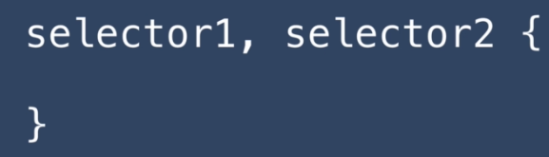When you want to apply similar styles to 2 or more tags,ids or classes you can do so by separating them using the commas.
* For Eg: If you wanna give both h1 and p the same color then you can do so by:

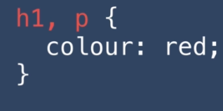

* Hierarchal selectors, they are read from right to left.

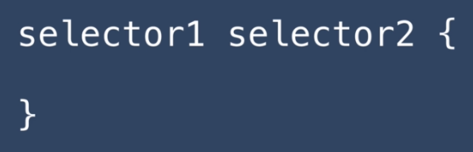

* In this scenario the first selector is from parent while the second selector is from the child. For example: here h1 is inside the div element.



* In the case below we want all the h1 elements inside the class container-fluid to have red color.



* Combined Selectors (with no space between selector name). They are read from left to right. They have to all occur in the same element.

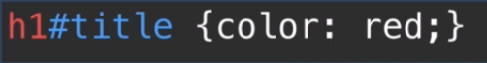

* Here we are targeting all h1s that have id of title.
* When you apply combined selectors all of the selectors have to be in the same html element



* Here h1 has 2 classes of title and container, to select h1 from combined selectors we can type

.title.container{  
//style

}

* Or if you wanna target it using hierarchal selectors, you can do so using

.container .title{

//style

}

* Ids get preference over classes, and classes get preference over tags. Id>class>tag

**Lecture No 11**

**Lecture No 12**

**Lecture No 13**